# **Power BI Desktop setup instructions**

***Note:*** Before jumping in, please make sure you have:

* A PC with Windows OS. Power BI does not work on a Mac OS.
* A Microsoft account with a Power BI license. The steps to sign up for a free Power BI license or purchase the Pro license are [**here**](https://docs.microsoft.com/en-us/power-bi/fundamentals/service-self-service-signup-for-power-bi)**.** Power BI requires that you use a work or school email address. You can't sign up or purchase using email addresses provided by consumer email services or telecommunication providers. This includes outlook.com, hotmail.com, gmail.com, and others. If you don't have a work or school account, [learn about alternate ways to sign up.](https://docs.microsoft.com/en-us/power-bi/admin/service-admin-signing-up-for-power-bi-with-a-new-office-365-trial) You will use this email address to sign into Power BI Desktop after it is installed.

To download Power BI Desktop:

1. Launch the browser and enter this [link](https://www.microsoft.com/en-us/download/details.aspx?id=58494) to access the Microsoft website. Now click on the **Download** button.

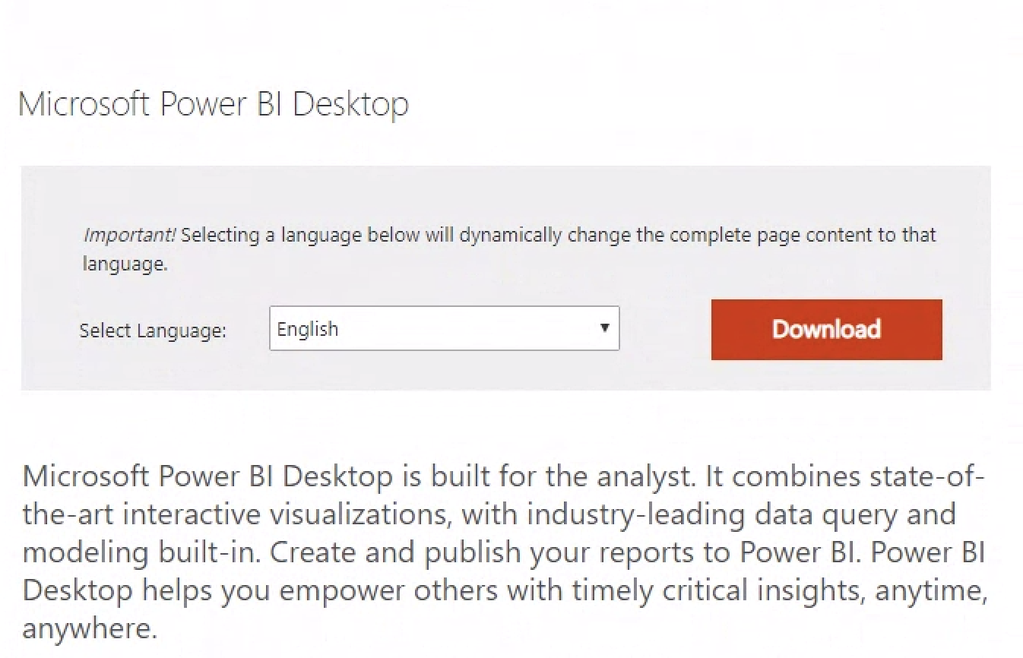

1. Based on the system requirements, download the setup file for installing Power BI. In this case, we have chosen the 64-bit version.

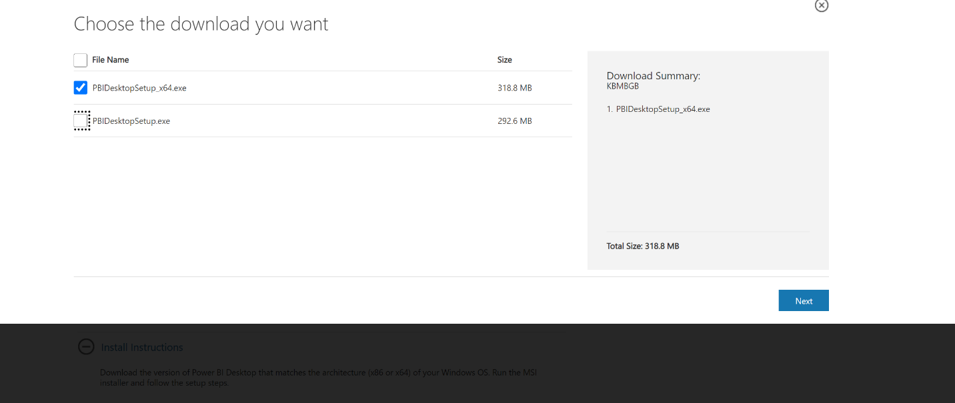

1. Once the setup file has been downloaded successfully, launch the setup to begin the installation.
2. Once the setup is launched, Click Next -> Select the language as English -> Accept the License agreement -> Use the default installation location and click Next and finally click on Finish once the application gets installed.

1. Once Power BI Desktop has been installed successfully, the application usually launches directly for the first time. If it doesn’t launch the application by clicking on Power BI Desktop icon or by typing in Power BI Desktop in your search box below.
2. Here’s what the Power BI desktop interface looks like:

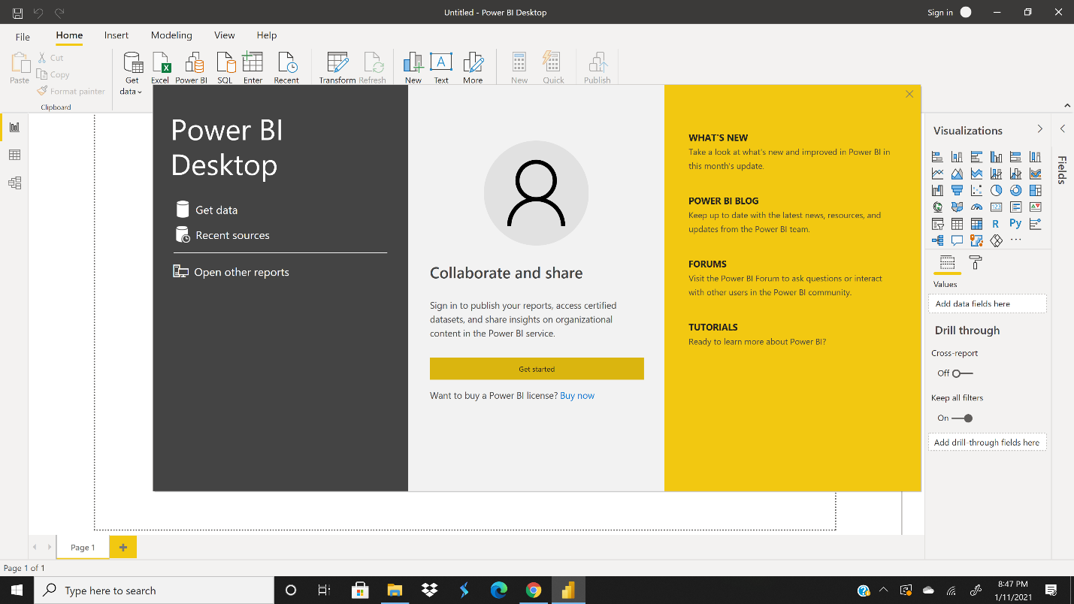

1. To sign into Power BI, click on the **Get started** button and enter the sign-in credentials using your Microsoft account.

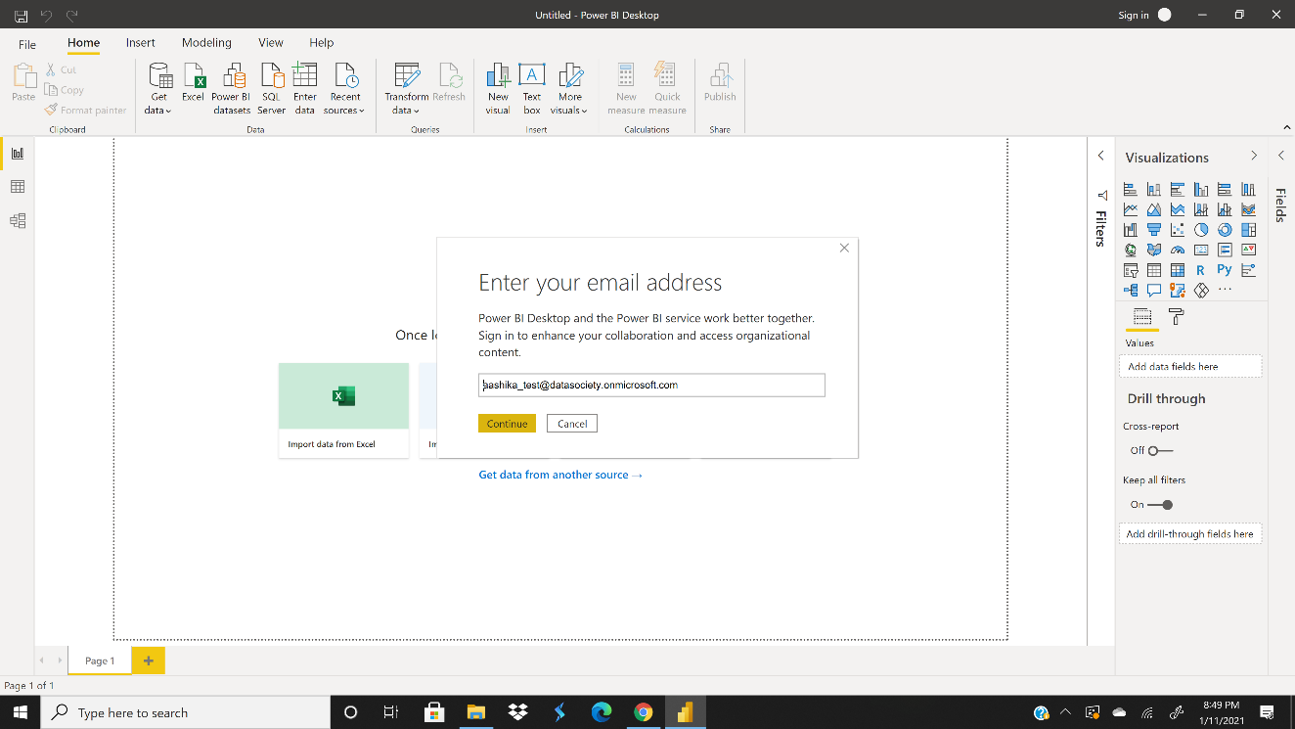

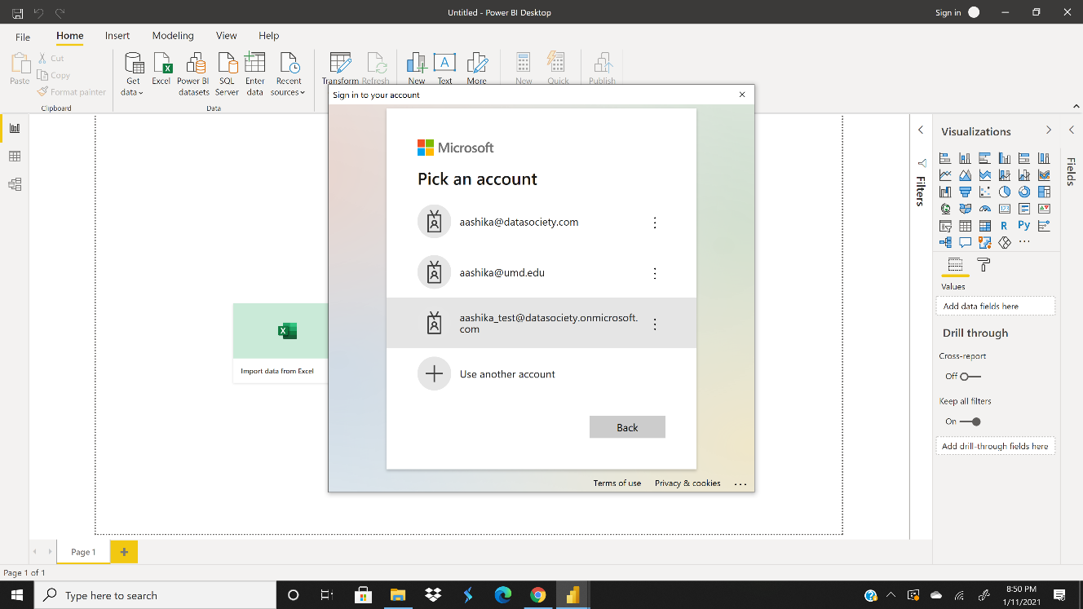

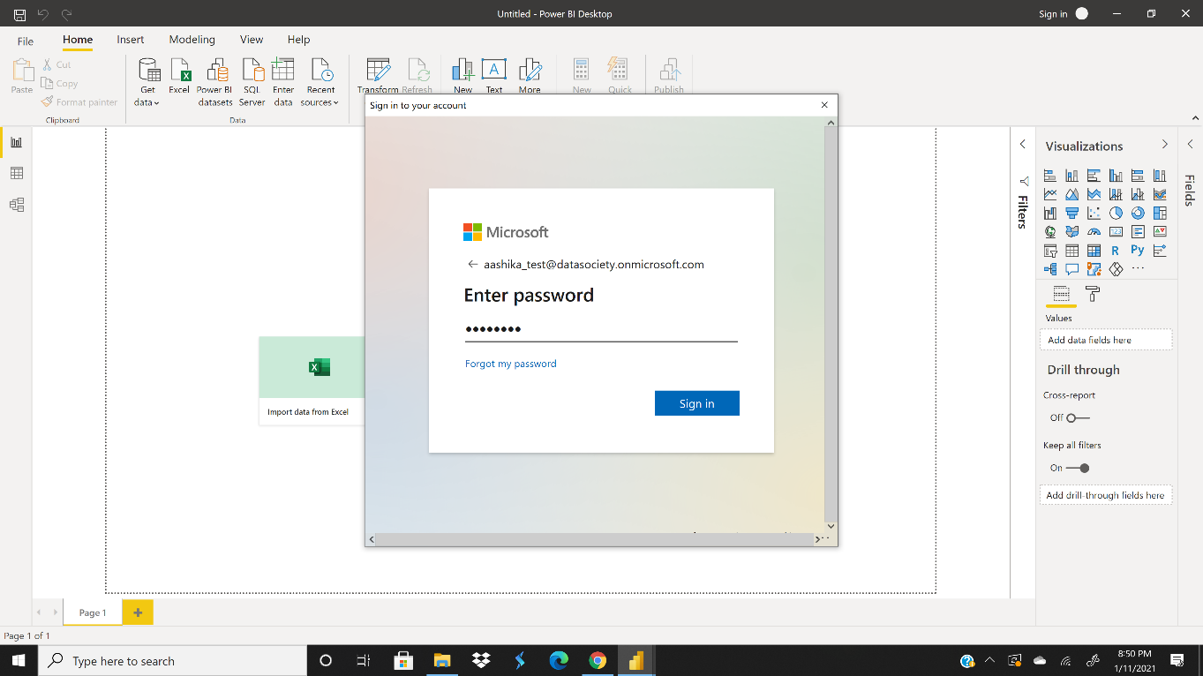

***Note:*** If a site blockage message comes, click on Add. Restart Power BI and try again.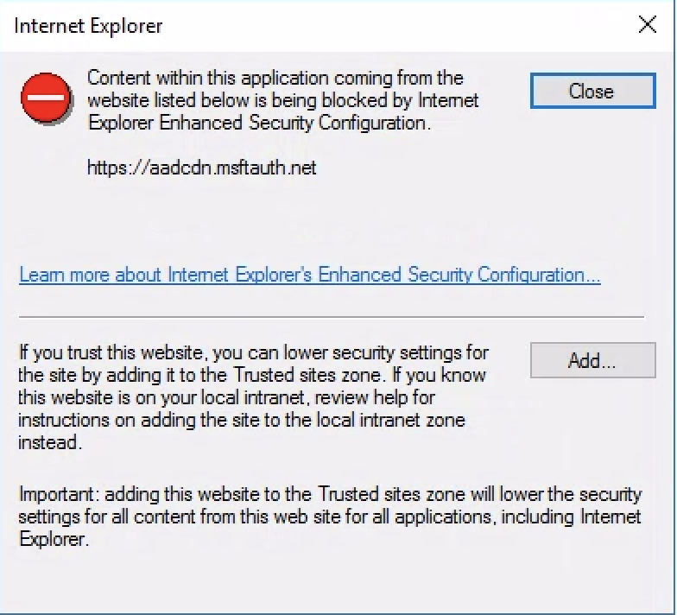

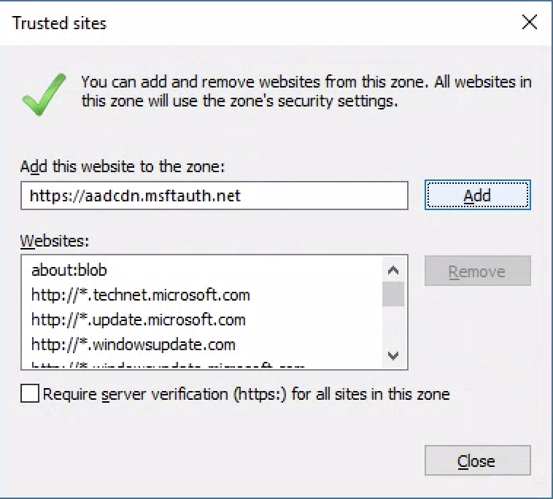

1. Once you have been signed-in successfully, you will be able to see the account name in the top-right corner of the ribbon as shown below.

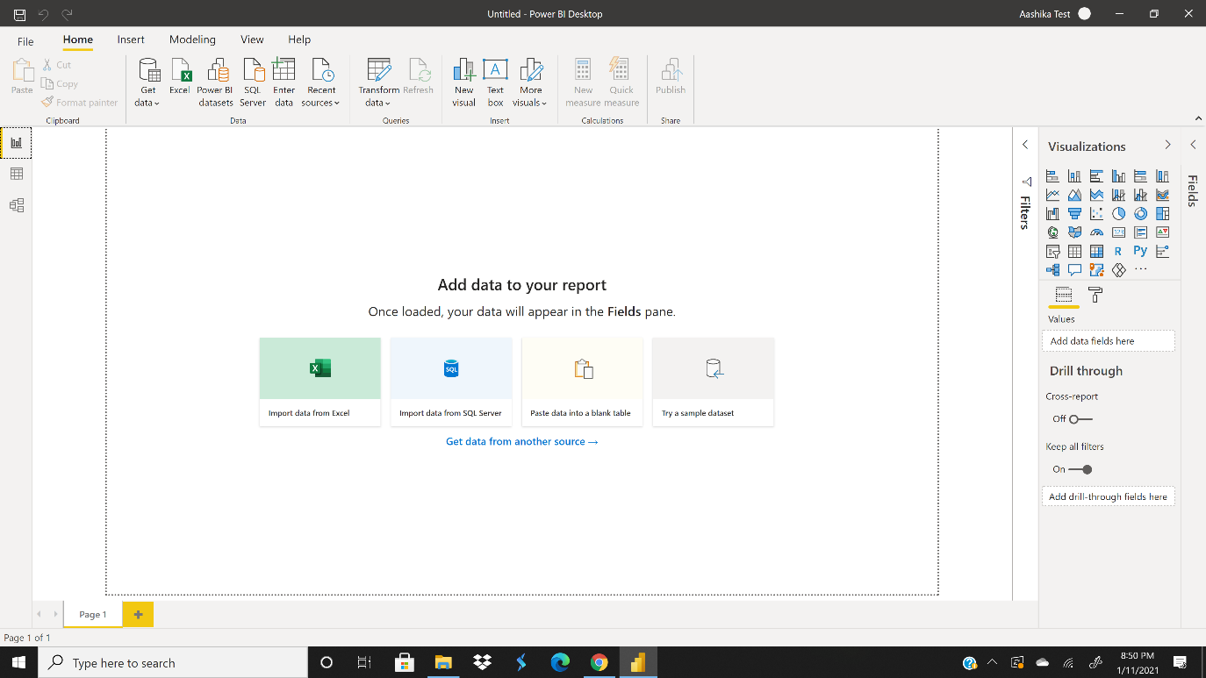

1. Since you have signed into Power BI, you would successfully be able to publish your workspaces using Power BI Desktop to Power BI service.
2. To view your workspaces and published reports on Power BI service, use the same Microsoft credentials as before.

***Note:*** To share your workspaces, dashboards, apps etc. with your co-workers, Power BI offers a trial version of Power BI Pro which is available for free for the first 60 days.